Hino International Goodwill Association
- Membership Application -
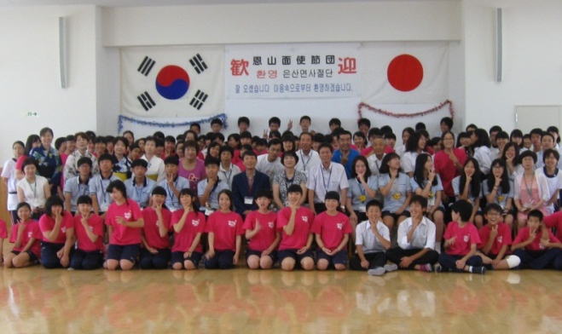
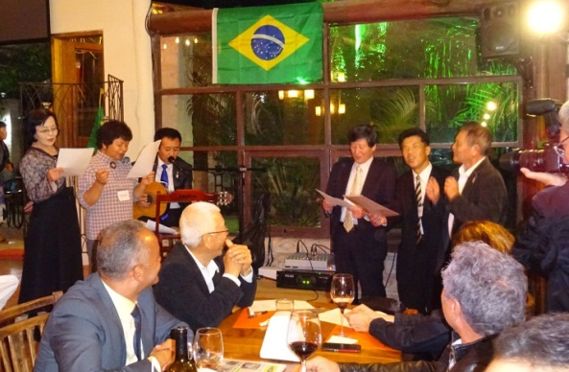
Hino Town formalized sister-city ties with Embu City, Brazil in May 1984 and Unzanmen, South Korea in May 1990. To deepen mutual understanding of each country’s educational systems and culture, as well as nurture a sense of friendship between as many people as possible around the world, the Hino International Goodwill Association was established in 1990. New members are welcome and integral to furthering the Association’s objectives.
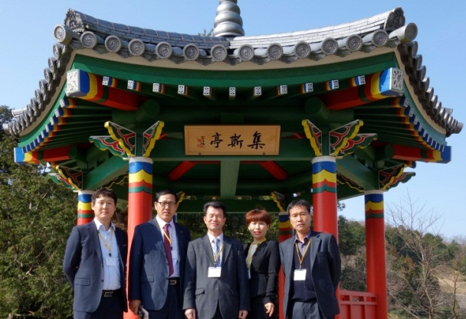

◆ | Appellation | Hino International Goodwill Association
◆ | Mailing Address | 1-1 Kawahara, Hino-cho, Gamo-gun, Shiga-ken 〒529-16９８
 |  | c/o Public Relations Section, Planning Division, Hino Town Office
◆ | Contacts | Telephone: 0748-52-6550 Fax: 0748-52-0089  E-mail: kouhou@town.shiga-hino.lg.jp
◆ | Head | President: Sakayu OKUDA
◆ | Year Founded | January 27, 1990
◆ | Activities | ・Exchange of Delegations: |  |  | Embu City, Brazil / Unzanmen, South Korea
 |  | ・Junior High Student Exchanges: |  |  | Unzanmen, South Korea
 |  | ・Promotion of Local Products: |  |  | Ujisato Matsuri“Rakuichi Rakuza”
 |  | ・Other: | Korean language classes, history tours, “Yuko no Wa” newsletter, hosting visitors from abroad, and international exchange promotion
◆ | Membership | 191 Individual Members １６ Corporate Members (Current as of May 2015)
◆ | Annual Fee | Individuals: 1,000 Yen / Corporations: 5,000 Yen
◆ | Bank Account Information | The Shiga Bank |  | Hino Branch |  | Futsu | １５２９００
 |  | Kansai Urban Bank |  | Hino Branch |  | Futsu | ２１６７００
 |  | Koto Shinkin Bank |  | Hino Branch |  | Futsu | ０２０８８８７
 |  | JA Green Omi Agricultural Co-perative |  | Hino Higashi Branch |  | Futsu | ５６７８５９５
◆ | Account Holder | Hino-cho Kokusai Shinzen Kyokai Kaicho Okuda Sakayu
◆ | Payment Methods | Make payment in cash to the Association’s office OR via bank deposit.  *If using the bank deposit method, a bank handling fee will be assessed.

↓Detach Here↓

Hino International Goodwill Association - Membership Application (apply by fax or e-mail)
I agree with the aims of the Hino International Goodwill Association and herby apply for individual / corporate [circle one] membership. *Please use one form per applicant.
Signature: |  |  |  | Date:
Individual or Corporate Name |  |  |  |  | Age | Sex
 |  |  |  |  |  | M / F
Mailing Address | 〒 －
Telephone |  | FAX
Cell/Mobile Phone |  | E-mail

